ZIDAFAMOR B. ONDUTIMI
17/ENG03/060
CIVIL ENGINEERING
1a) Methods of levelling
Height of collimation system
Advantages
- It is rapid as it involves few Calculation
- There are two checks on the accuracy of RL calculation
- This system is suitable for longitudinal leveling where number of intermediate sights
- Visualization is not necessary regarding the nature of the ground
Disadvantages
- There is no check on the RL of the intermediate sight
- Errors in the intermediate RLs cannot be detected.

Rise and fall system
Advantages
- There is a check on the RL of the intermediate points
- Errors in the intermediate RLs can be detected as all the points are correlated
- There are three checks on the accuracy of RL calculation
- This system is suitable where there are no intermediate sights
Disadvantages
- It is laborious involving several calculations.
- Visualization is necessary regarding the nature of the ground

1b)
RL=110+matric No.=110+60=170
B.S | I.S | F.S | H OF C | R.L | DISTANCE | REMARKS
0.771 |  |  | 170.771 | 170 | 0 | RL
0.802 |  | 1.52 | 170.053 | 169.251 | 10 | CP
 | 2.311 |  |  | 167.742 | 20
3.580 |  | 1.990 | 171.643 | 168.063 | 30 | CP
 | 1.220 |  |  | 170.423 | 40
 | 3.675 |  |  | 167.968 | 50
2.408 |  | 4.020 | 170.031 | 167.623 | 60 | CP
 | 0.339 |  |  | 169.692 | 80
0.780 |  | 0.157 | 170.654 | 169.874 | 90 | CP
 | 1.535 |  |  | 169.119 | 100
 | 1.955 |  |  | 168.699 | 110
 | 2.430 |  |  | 168.224 | 120
 | 2.985 |  |  | 167.669 | 130
1.155 |  | 3.480 | 168.329 | 167.174 | 140 | CP
 | 1.960 |  |  | 166.369 | 150
 | 2.365 |  |  | 165.964 | 160
0.935 |  | 3.640 | 165.624 | 164.689 | 170 | CP
 | 1.045 |  |  | 164.579 | 180
 | 1.630 |  |  | 163.994 | 190
 |  | 2.545 |  | 163.079 | 200
$Σ$=10.431 |  | $Σ$=17.352

HC=RL+BS
HC(1)=170+0.711=170.771
RL=HC-FS
RL(1)=170.771-1.52=169.251
HC(2)=169.251+0.802=170.053
RL(2)=170.053-2.311=167.742
RL(3)=170.053-1.990=168.063
HC(3)=168.063+3.580=171.643
RL(4)=171.643-1.220=170.423
RL(5)=171.643-3.675=167.968
RL(6)=171.643-4.020=167.623
HC(4)=167.623+2.408=170.031
RL(7)= 170.031-0.339=169.692
RL(8)= 170.031-0.157=169.874
HC(5)=169.874+0.780=170.654
RL(9)= 170.654-1.535=169.119
RL(10)= 170.654-1.955=168.699
RL(11)= 170.654-2.430=168.224
RL(12)= 170.654-2.985=167.669
RL(13)= 170.654-3.480=167.174
HC(6)=167.174+1.155=168.329
RL(14)= 168.329-1.960=166.369
RL(15)= 168.329-2.365=165.964
RL(16)= 168.329-3.640=164.689
HC(7)=164.689+0.935=165.624
RL(17)= 165.624-1.045=164.579
RL(18)= 165.624-1.630=163.994
RL(19)= 165.624-2.545=163.079

QUESTION 2

Chainage(m) | 0 | 30 | 60 | 90 | 120 | 150 | 180 | 210 | 240 | 270
Offset length(m) | 0 | 2.65 | 3.80 | 3.75 | 4.65 | 3.60 | 5.00 | 5.80 | 6.10 | 5.85

Using Mid-ordinate rule:
A=$Σ$hd

h1= $\frac{0+2.65}{2}$=1.325m

h2= $\frac{2.65+3.80}{2}$=3.225m

h3= $\frac{3.80+3.75}{2}$=3.775m

h4= $\frac{3.75+4.65}{2}$=4.2m

h5= $\frac{4.65+3.60}{2}$=4.125m

h6= $\frac{3.60+5.00}{2}$=4.3m

h7= $\frac{5.00+5.80}{2}$=5.4m

h8= $\frac{5.80+6.00}{2}$=5.9m

h9= $\frac{6.00+5.85}{2}$=5.925m

$$Σh=1.325+3.225+3.775+4.2+4.125+4.3+5.4+5.9+5.925$$
$Σh=$38.175m

d=30m
A=$Σhd$
= $38.175×30$
A= $1145.25m{}^{2}$

Using average ordinate rule

A=$\frac{ndΣO}{n+1}$

n=9

d=30
$$ΣO=0+2.65+3.80+3.75+4.65+3.60+5.00+5.80+6.10+5.85$$
$ΣO=$41.2m

A=$\frac{9×30×41.2}{9+1}$

A=$112.4m{}^{2}$

Using trapezoidal rule

A=$d(\frac{0{}_{1}+0{}_{n }}{2}+0{}_{2}+0{}_{3}+0{}_{4}............0{}_{n-1})$

$$d=30$$

A=$30(\frac{0+5.85}{2}+2.65+3.80+3.75+4.65+3.60+5.00+5.80+6.10)$

A=$30(38.275)$
A=$1148.25m{}^{2}$

Using Simpson's rule
$$A=\frac{d }{3 }\left[\left(0{}_{1}+0{}_{n}\right)+4\left(0{}_{2}+0{}_{4}+.........0{}_{n-1}\right)+2\left(0{}_{3}+0{}_{5}........0{}_{n-1}\right)\right]$$

$$d=30$$

Note: Last offset was removed because number of offsets were even

$$A=\frac{30}{3 }\left[\left(0+6.10\right)+4\left(2.65+3.75+3.60+5,80\right)+2\left(3.80+4.65+5.00\right)\right]$$
$$A=962m{}^{2}$$

Calculating for last offset using trapezoidal rule

A=$d(\frac{0{}_{1}+0{}_{n }}{2}+0{}_{2}+0{}_{3}+0{}_{4}............0{}_{n-1})$

$$A=30\left[\frac{6.40+5.85}{2}\right]$$
$$A=183.75m{}^{2}$$

Therefore $ΣA=962+183.75$

$$A=1145.75m{}^{2}$$

2b.

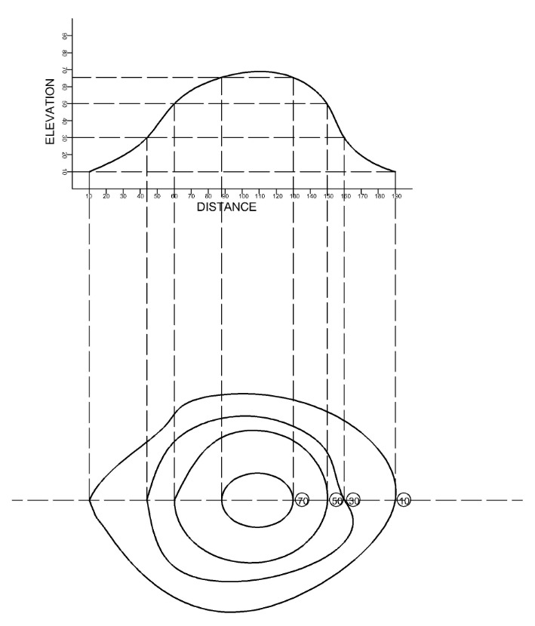
A series of close contour lines represents a hill if the higher values are inside as shown above.

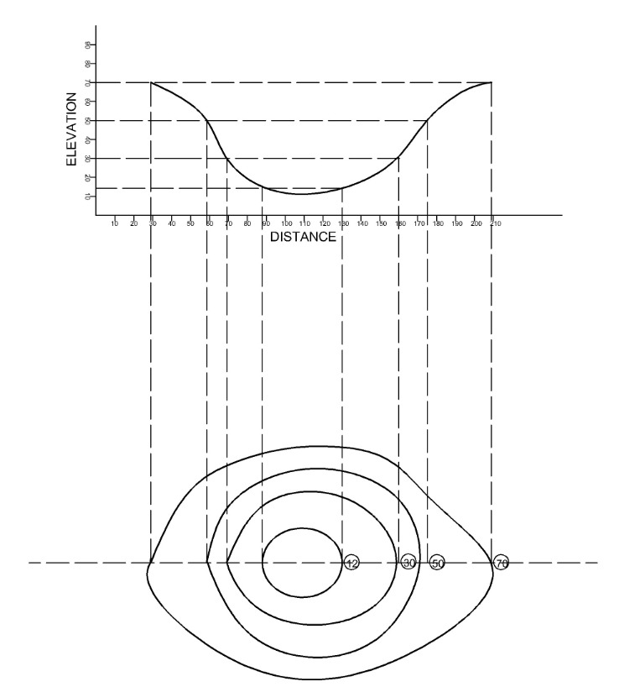
A series of close contours on a map indicates a depression if the higher values are outside as shown above.

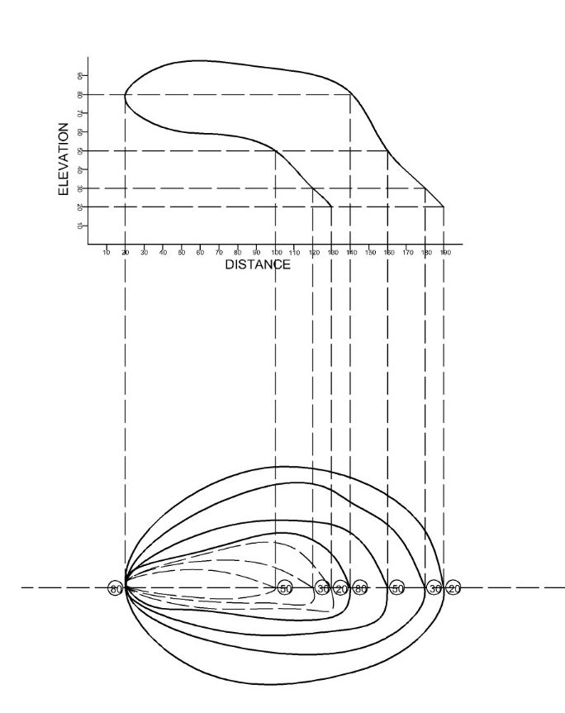
Contour lines cannot merge or cross one-another on a map except in the case of an over-hanging cliff

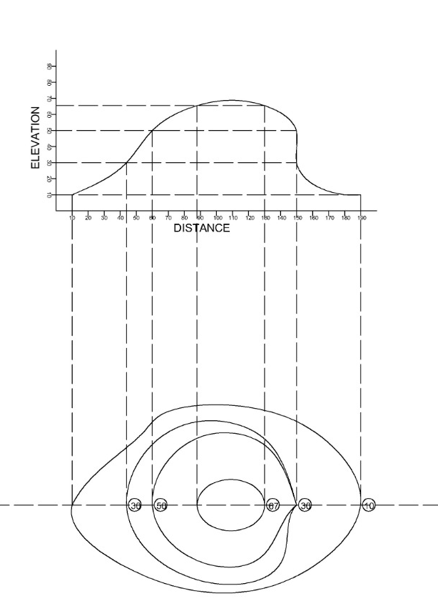
Contours never run into one another except in the case of a vertical cliff. In this case several contours coincide and the horizontal equivalent becomes 0.

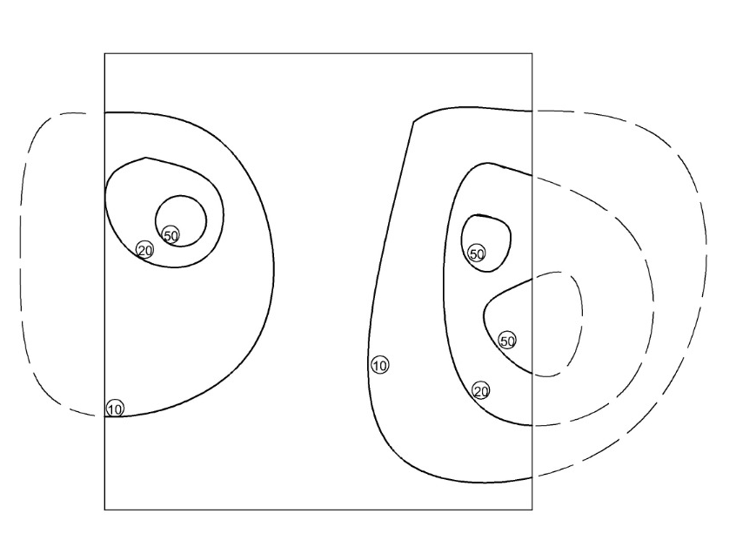
Contour lines cannot end anywhere but close on themselves either within or outside the limits of the map.

